Snowsql error

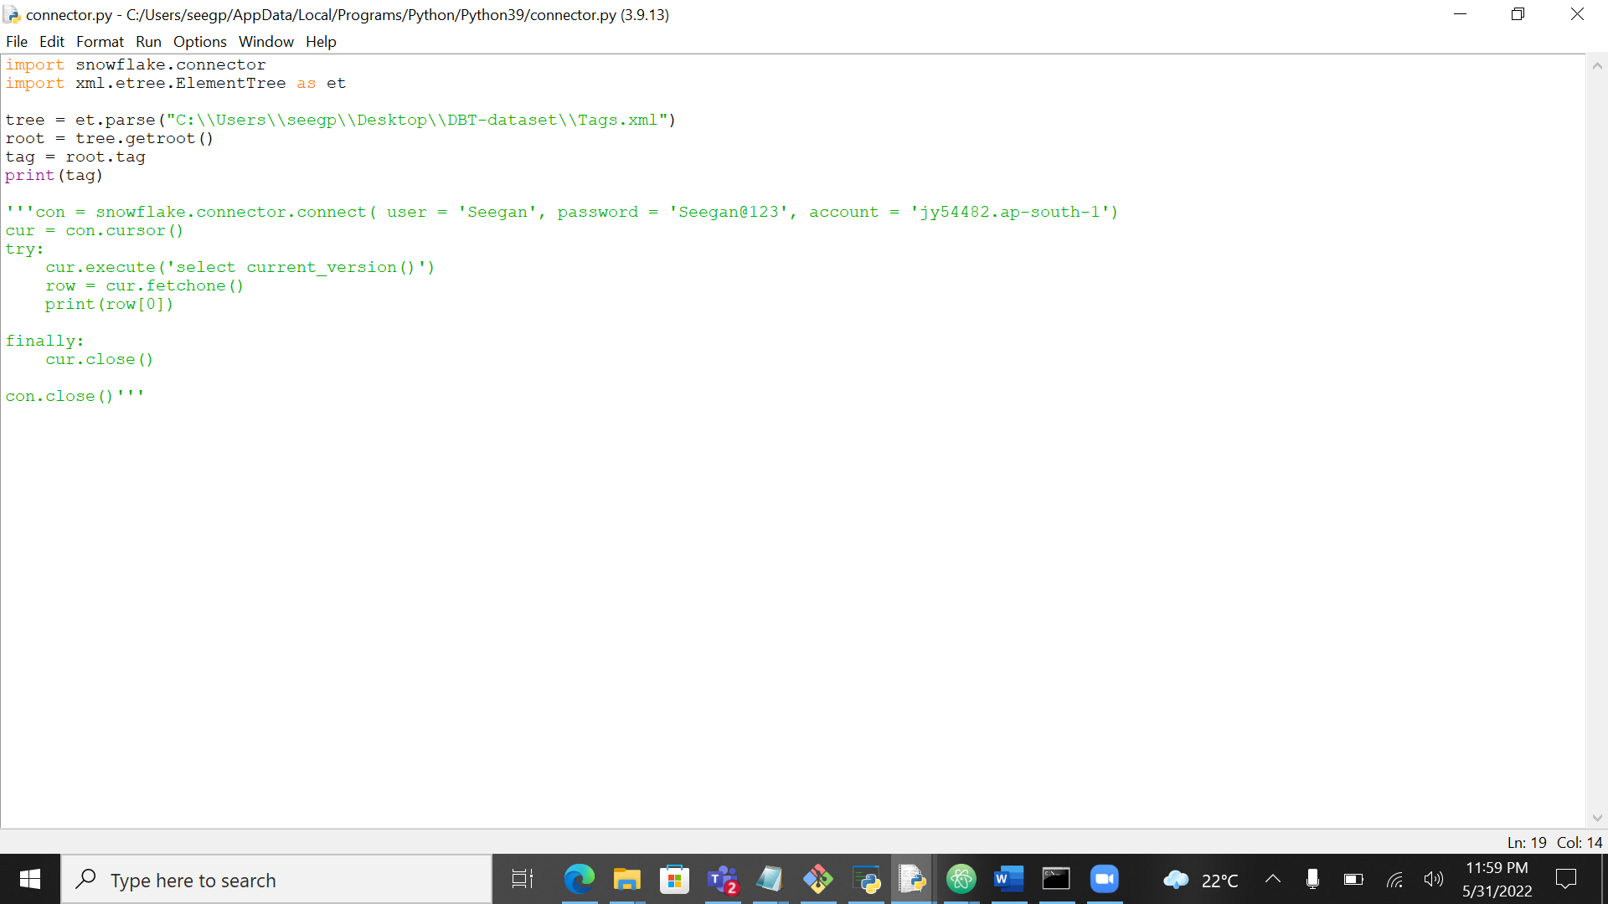

In python I was not able to read the attributes of xml

Manual method